**Math**

Standards Review

**Homework:**

* **Monday:** none
* **Tuesday:** none
* **Wednesday**: none
* **Thursday:** none

**Mississippi History**

Global Trade for Mississippi

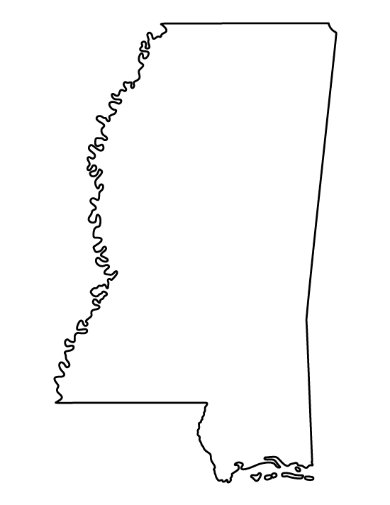

**Science**

**In Class:** The Human Body

**Language Arts:**

*Tuck Everlasting*

**Homework:**

* **Monday: none**
* **Tuesday: none**
* **Wednesday: none**
* **Thursday**: None

**Reminders:**

* Students can bring a snack and CLEAR water bottle (with water only) to school each day. They are allowed to use the bottle fillers on each hallway.
* Students will not be able to change their mode of afternoon transportation (bus, car, or van), unless it is a permanent change with a parent note. (Student Handbook pg. 18)
* Students who have 10+ unexcused absences or 20+ combined tardies/check-outs will NOT be eligible for any field trips. (Student Handbook pg. 76)
* All classroom treats must have the original store-bought nutritional label. (Student Handbook pg. 76)

**Dates to Know**

* **May 16:** 4th Grade Awards Day (12:00 for Cook and Sistrunk)
* **May 21:** Field Day
* **May 24:** Last Day of School (60% day)

**Pirate Treasures Newsletter**

Scan the QR code to see what’s happening around PUE!

